First Announcement
"Snow cover, precipitation, aerosols"  June 17–21, 2024  Irkutsk National Research Technical University  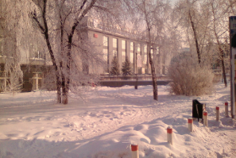 | Welcome to VI Baikal conference “Snow cover, precipitation, aerosols”, Irkutsk  VI Baikal international scientific conference – strategic session “Snow cover, precipitation, aerosols” will be held in Irkutsk and Listvyanka  (63 km from Irkutsk, Lake Baikal)  The main topics of the conference:  1. Research methodology  2. Snow cover, precipitation, aerosols  3. Sustainable development  4. Winter technologies  5. Humanities and social sciences  6. Science and art | 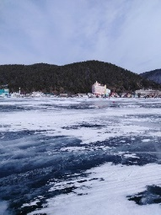
 |  | 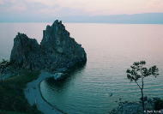

The conference provides a platform for researchers and practitioners to exchange the knowledge on the study of snow cover, precipitation, aerosols and related user services. It covers a wide range of topics that will interest expert scientists, as well as professionals in industry, administrative management and decision-makers in the field of economic activity.

Registration and accommodation
The online registration will be open at February 1, 2024 at the Conference web site http://snow-baikal.tw1.ru/. The registration on the web site is required. The registration fee for a regular participant does not include payment for accommodation and meals.

 | Registration fees (in RUB)
Regular participant | 40 000 *
Distant participant | 3 000 –5 000 **
Online participant | free
* The fee reducing is possible; please check the terms for the participation with the organizers by e-mail conference@snow-baikal.rub before payment.
** Proceedings of conference will be posted on the www.elibrary.ru portal. The abstracts have to be submitted before April 1st, 2024 using the online registration form or by e-mail.
Accommodation of non-resident participants is planned in the hotel "Mayak" located on the shore of Baikal Lake in the village of Listvyanka. Participants reserve their own accommodation on the hotel website independently http://www.mayakhotel.ru , with a pre-approved 10-15% discount (book directly on the hotel website or by calling the hotel).

Exemplary scientific excursion program
Baikal Museum of the SB RAS with a visit to the arboretum
Port Baikal / Museum of the History of the Circum-Baikal Railway
Astrophysical Observatory "Solar Wind"
Architectural and Ethnographic Museum "Taltsy" / Taltsy village

Please clarify the information in correspondence e-mail: conference@snow-baikal.ru and/or on the website http://snow-baikal.tw1.ru/

Information on previous sessions of the Conference
2023 V Baikal “Snow cover, precipitation, aerosols” https://www.istu.edu/news/73084
2022 IV Baikal “Snow cover, precipitation, aerosols” https://www.istu.edu/news/67726/
2021 III Baikal “Snow cover, precipitation, aerosols: chemistry and climate https://www.istu.edu/news/61545/ https://iupac.org/event/snow-cover-atmospheric-precipitation- aerosols-chemistry-and-climate
2018 II Baikal “Snow cover, precipitation, aerosols: technology, climate and ecology” https://www.istu.edu/news/44917
2017 I Baikal “Snow cover, precipitation, aerosols: ecology of the northern territories and the Baikal region” http://www.istu.edu/news/29811
2017 Field seminar “Theoretical and applied aspects of snow cover research: Southern Baikal” https://www.istu.edu/news/37614

Chairman of the organizing technical committee:
Director, Ph.D., Antsiferov Evgeniy, tel., 83952 405120, antsiferov@istu.edu
Chairman of the program committee: Leading specialist, Doctor of Science in Engineering, Natalia Ianchenko, tel., 89501018946, fduecn@bk.ru, fduecn@ex.istu.edu, conference@snow-baikal.ru
Coordinator for general issues: Associate Professor, Ph.D., Ognev Igor, tel., 89149426951 ognev@ex.istu.edu , conference@snow-baikal.ru
Acceptance of materials for publication on the website: Associate Professor, Ph.D., Arshinsky Vadim, arshinskyv@mail.ru

